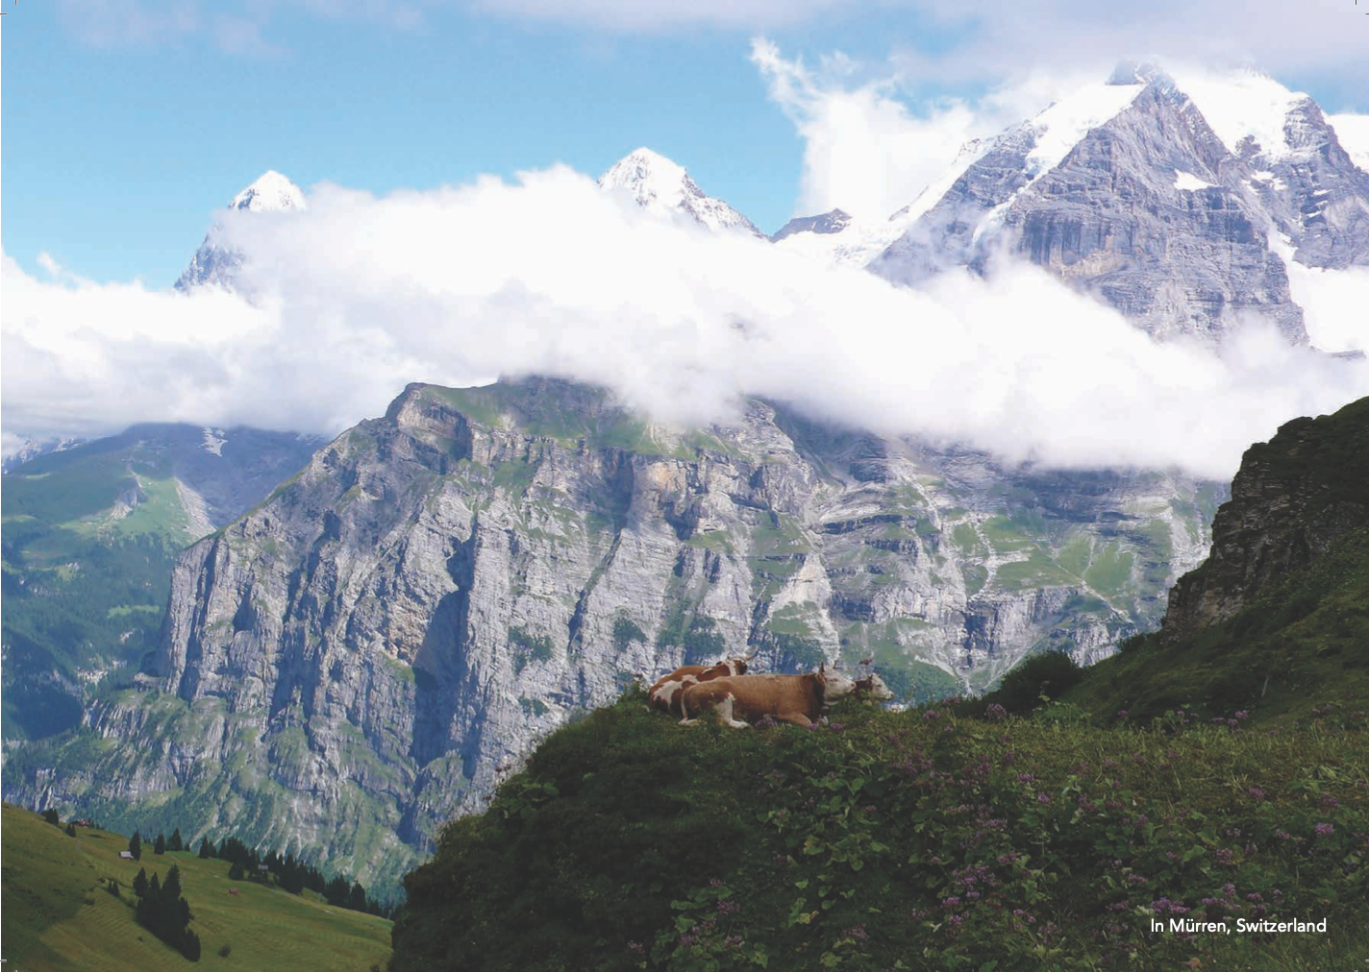

2023 Mürren International Gathering around the work of

J. KRISHNAMURTI 24 June – 8 July

Themes and 2-week programme below

All information and reservations with Claire

claratolo@gmail.com

KRISHNAMURTI GATHERING 2023 in Mürren, Switzerland - Week 1 (24 June to 1 July 2023): What is love?

 | Saturday  24 June 2023 | Sunday  25 June 2023 | Monday  26 June 2023 | Tuesday  27 June 2023 | Wednesday  28 June 2023 | Thursday  29 June 2023 | Friday  30 June 2023 | Saturday  1 July 2023
7h30 |  | Breakfast | Breakfast | Breakfast | Breakfast | Breakfast | Breakfast | Breakfast
9h00 |  | Music or silence  Video  SA76T5  Suffering and love (69 minutes) | Music or silence  Audio  SA68T5  Living is the beauty of action and love  (52 minutes) | Walk in the mountains | Music or silence  Audio  SA68T6  Pleasure, love, beauty and loneliness  (65 minutes) | Music or silence  Video  US66FRR5  What is love?  (29 minutes) | Music or silence  Video  SA80T5  The relationship of desire, will and love  (82 minutes) | Music or silence  Video  SA80T6  The ending of sorrow brings love and compassion  (79 minutes)
11h15 |  | Dialogue groups | Dialogue groups |  | Dialogue groups | Dialogue groups | Dialogue groups | Departure  Week 1
13h00 |  | Lunch | Lunch |  | Lunch | Lunch | Lunch
17h00 | Arrival  Week #1  Welcome meeting | Movements or  Walk with observation | Movements or  Walk with observation |  | Movements or  Walk with observation | Movements or  Walk with observation | Movements or  Walk with observation
19h00 | Supper | Supper | Supper | Supper | Supper | Supper | Supper
20h30 | Video extract  OJ81Q2-WQ03  On attachment and love  (21 minutes) | Video extract  SA83Q1-WQ02  I long to be loved. It is a constant anguish-What am I to do?  (14 minutes) | Video extract  SD72CES2-EX02  Love is total attention  (11 minutes) | Video extract  OJ77T4-EX01  Why is pleasure more dominant than love?  (16 minutes) | To Be Determined | Video extract  MA8081Q2-WQ03  On love and attachment  (8 minutes) | Video extract  SA78T5-EX01  When there is love all relationship changes  (15 minutes)
KRISHNAMURTI GATHERING 2023 in Mürren, Switzerland - Week 2 (1 July to 8 July 2023): There is an ending to sorrow

 | Saturday  1 July 2023 | Sunday  2 July 2023 | Monday  3 July 2023 | Tuesday  4 July 2023 | Wednesday  5 July 2023 | Thursday  6 July 2023 | Friday  7 July 2023 | Saturday  8 July 2023
7h30 |  | Breakfast | Breakfast | Breakfast | Breakfast | Breakfast | Breakfast | Breakfast
9h00 |  | Music or silence  Video  BR77T1  Is it possible to see the limitation of thought?  (62 minutes) | Music or silence  Video  BR77T2  What is the function of the brain?  (58 minutes) | Walk in the mountains | Music or silence  Video  BR77T3  What is at the very root of sorrow?  (63 minutes) | Music or silence  Video  BR77T4  Is the flowering of goodness a matter of time? (72 minutes) | Music or silence  Video  BR77D1  Is there such a thing as love?  (81 minutes) | Departure
11h15 |  | Dialogue groups | Dialogue groups |  | Dialogue groups | Dialogue groups | Dialogue groups
13h00 |  | Lunch | Lunch |  | Lunch | Lunch | Lunch
17h00 | Arrival  Week #2  Welcome meeting | Movements or  Walk with observation | Movements or  Walk with observation |  | Movements or  Walk with observation | Movements or  Walk with observation | Movements or  Walk with observation
19h00 | Supper | Supper | Supper | Supper | Supper | Supper | Supper
20h30 | Video extract  SA77T5-EX01  On suffering  (21 minutes) | Video extract  MA8182Q1-WQ03  What is sorrow?  (6 minutes) | Video extract  MA7879T5-EX01  Observing sorrow  (15 minutes) | Video extract  BR80Q1-WQ05  Is suffering needed to face the necessity to change?  (21 minutes) | To Be Determined | Video extract  SA78T6-EX01  Your sorrow is mankind's sorrow  (17 minutes) | Video extract  OJ77T5-EX02  Why do you tolerate suffering?  (24 minutes)

